**Lab Exercise-I**

**(Pair- Programming)**

**Deadline: Jan 29, 11:59PM through the Lab submission form & Canvas Turnitin**

**Please complete the below software Installations**

**Step 1: Install below softwares/technologies:**

* + 1. GitHub desktop and Gitshell
    2. Zen Hub Plugin
    3. Creatly account
    4. Web storm
    5. Brackets
    6. Ionic CLI
    7. Node and NPM

**Step 2: Capture screenshots for proof of installation for each software. Also create a wiki page for Lab-1 with the screen shots and small write up related to the installation.**

1. **Git Desktop**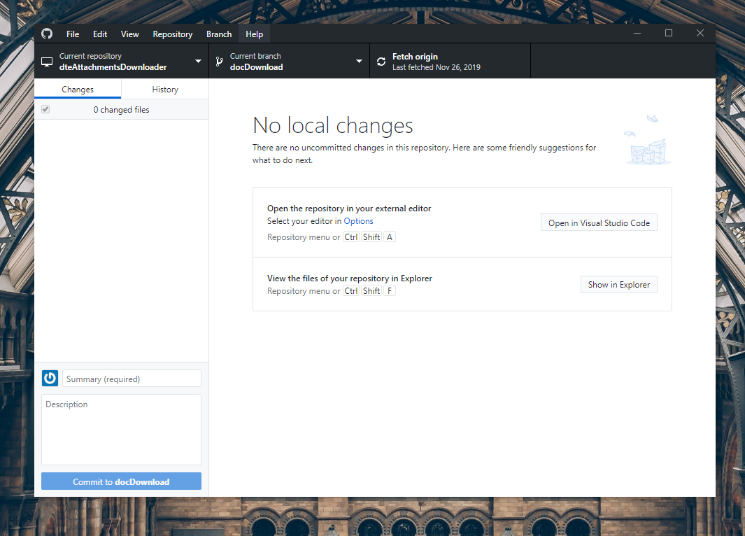
2. **Gitshell**

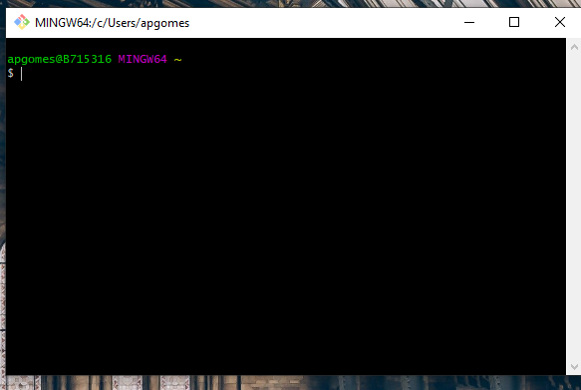

1. **Zenhub plugins**

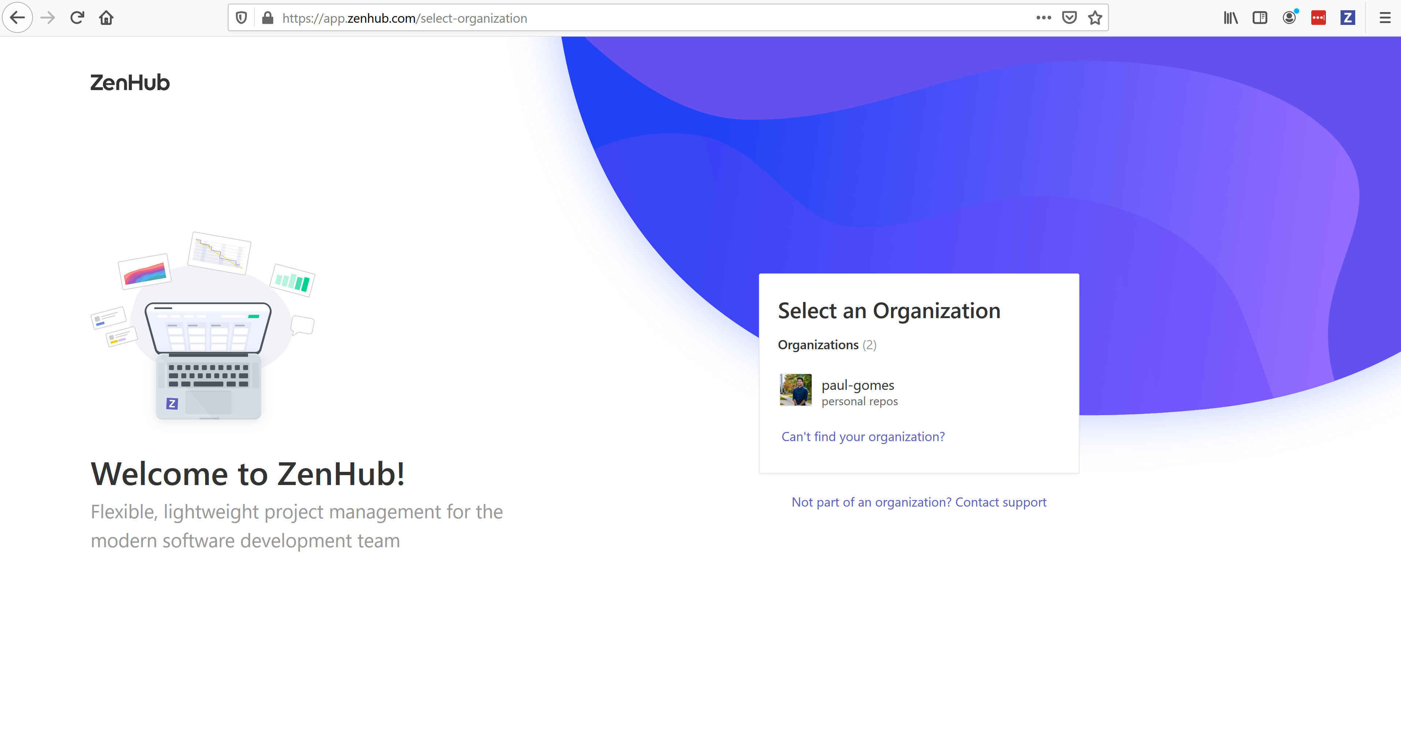

1. **Creatly**

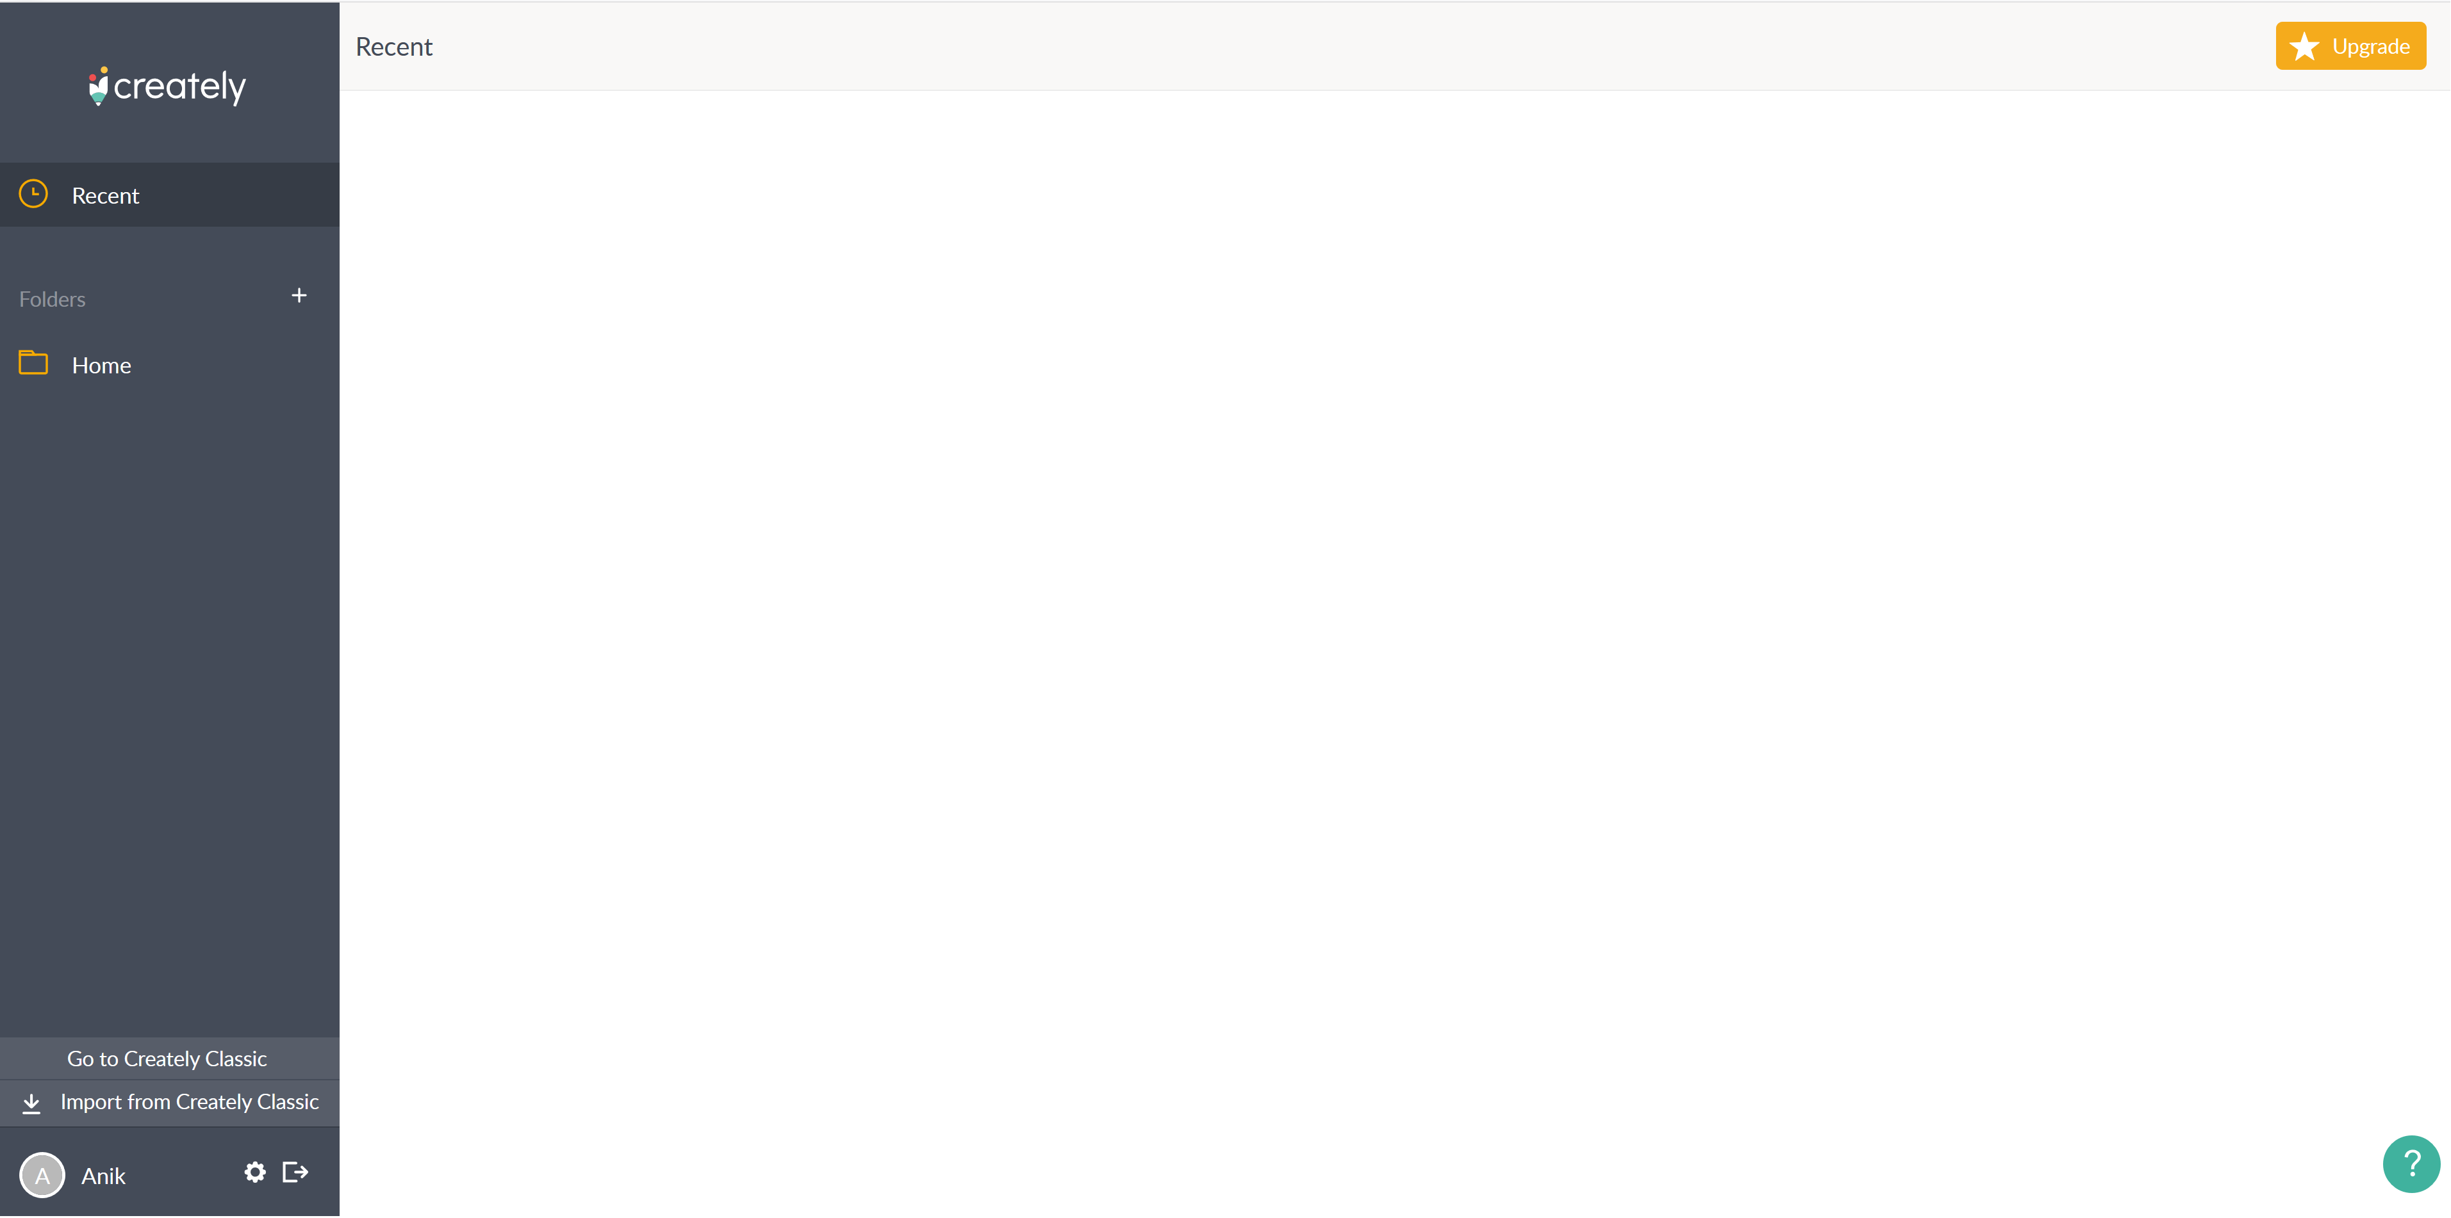

1. **Brackets**

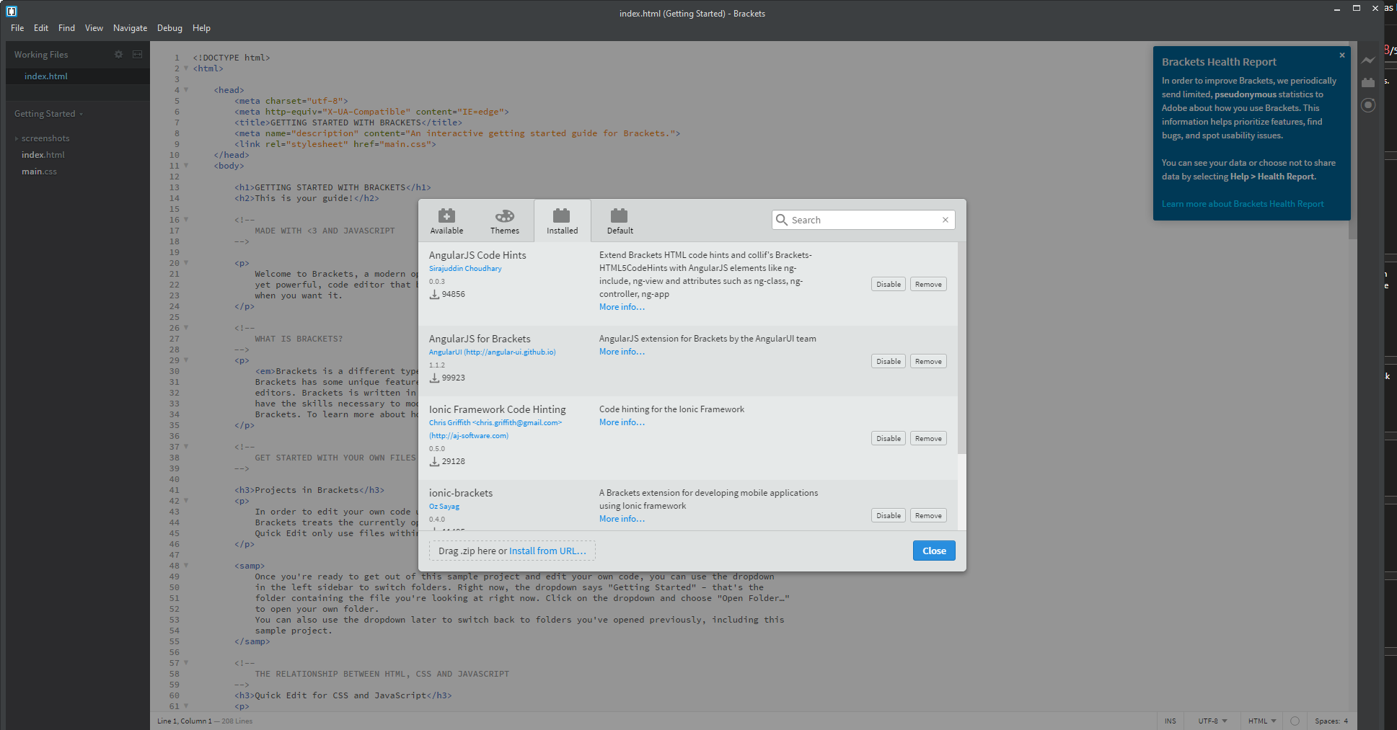

1. **Node**

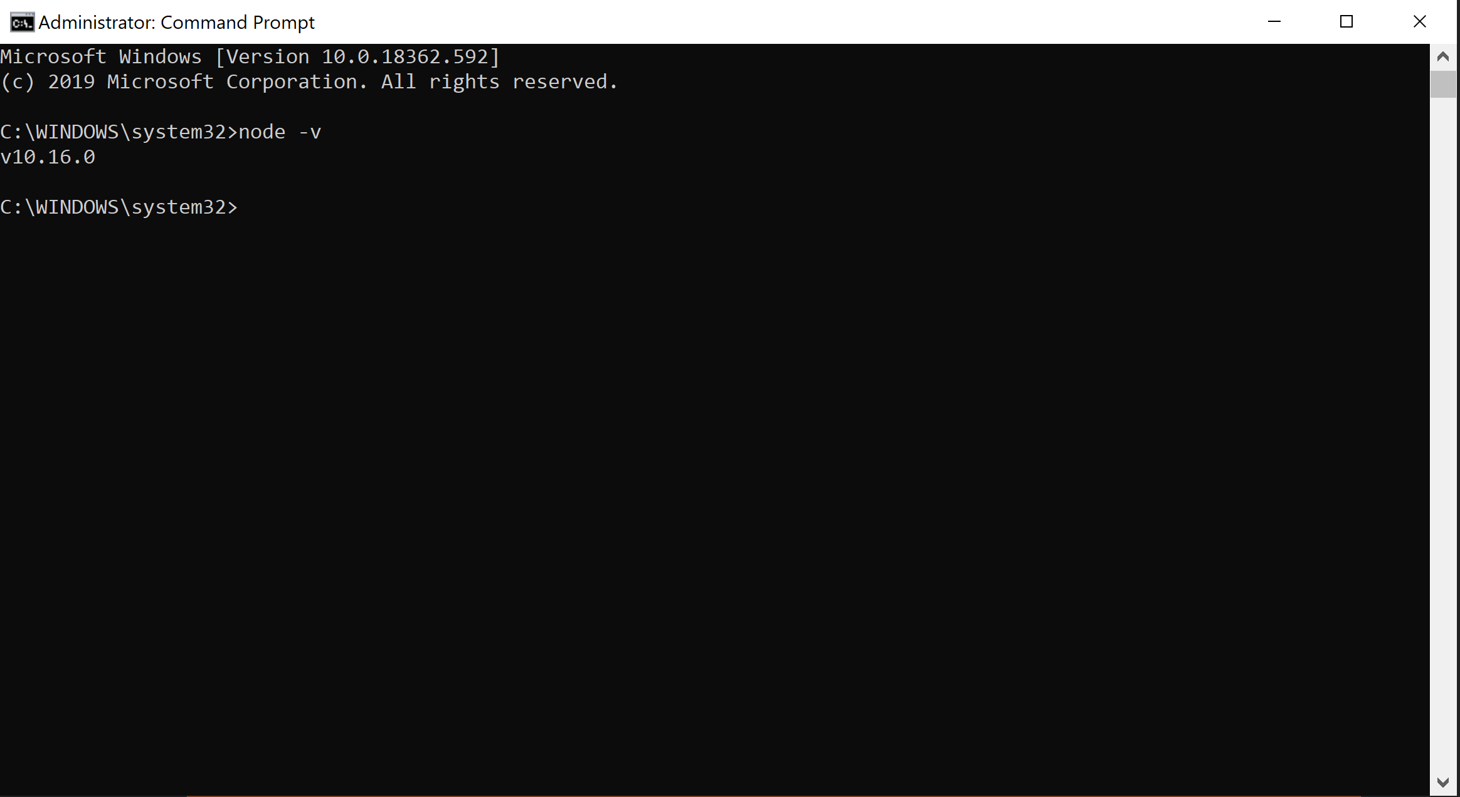

1. **Ionic cli**

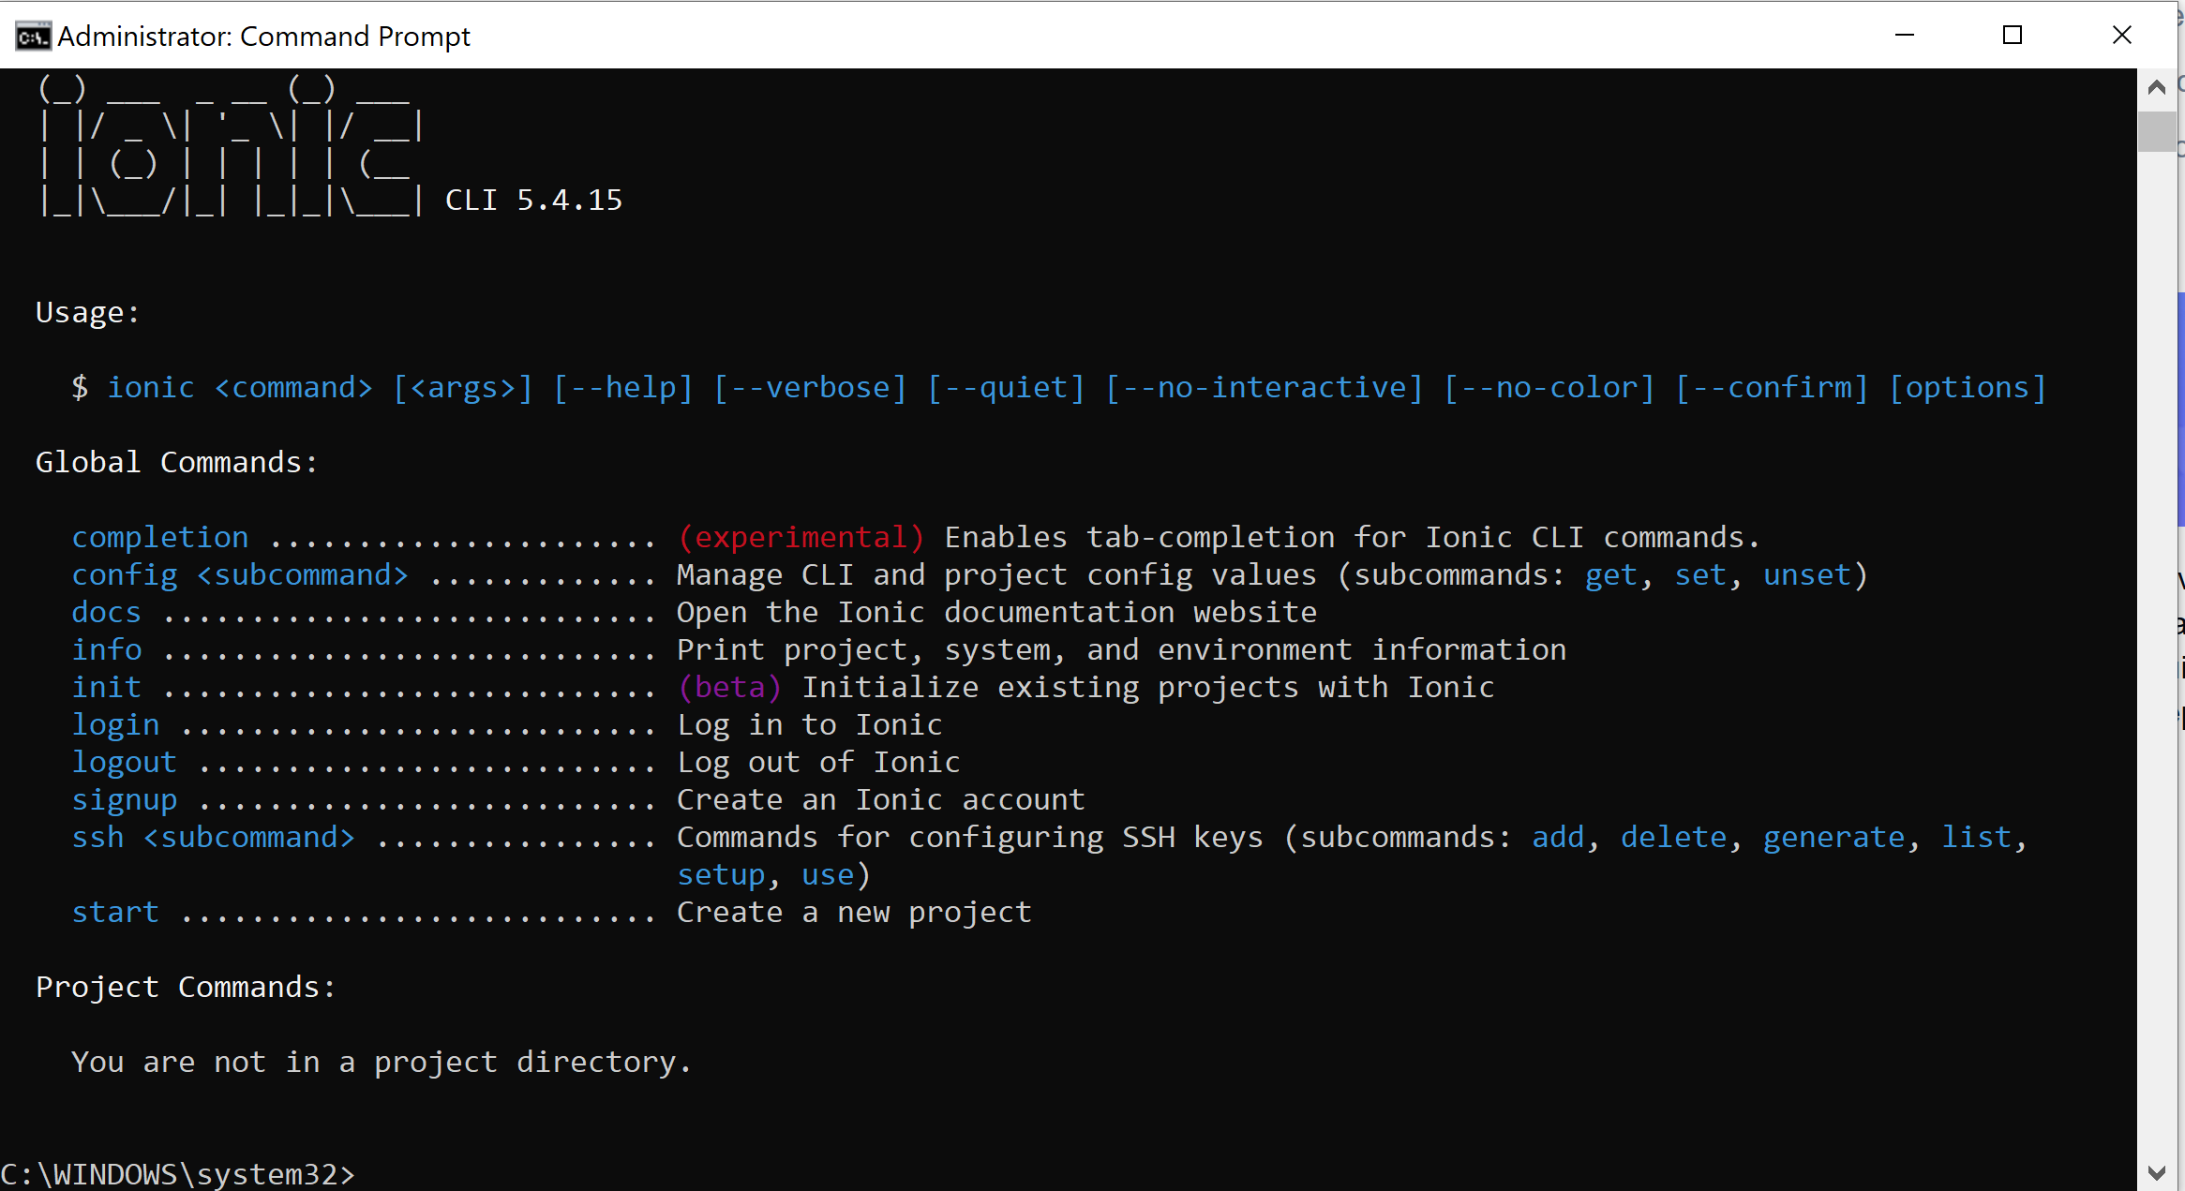

1. **VS Code (instead of Web storm)**

